1.API for bulk transaction creation :

a.curl url:

curl --location 'http://localhost:8080/api/transaction/createBulkTransaction' \

--header 'Content-Type: application/json' \

--data '{

"customerId": "9d1b96e2-14b1-46a4-847e-df4677a05100",

"transactions": [

{

"amount": 138,

"transactionDate": "2024-02-12"

},

{

"amount": 146,

"transactionDate": "2024-02-12"

}

]

}'

{

"customerId": "9d1b96e2-14b1-46a4-847e-df4677a05100",

"transactions": [

{

"amount": 138,

"transactionDate": "2024-02-12"

},

{

"amount": 146,

"transactionDate": "2024-02-12"

}

]

}

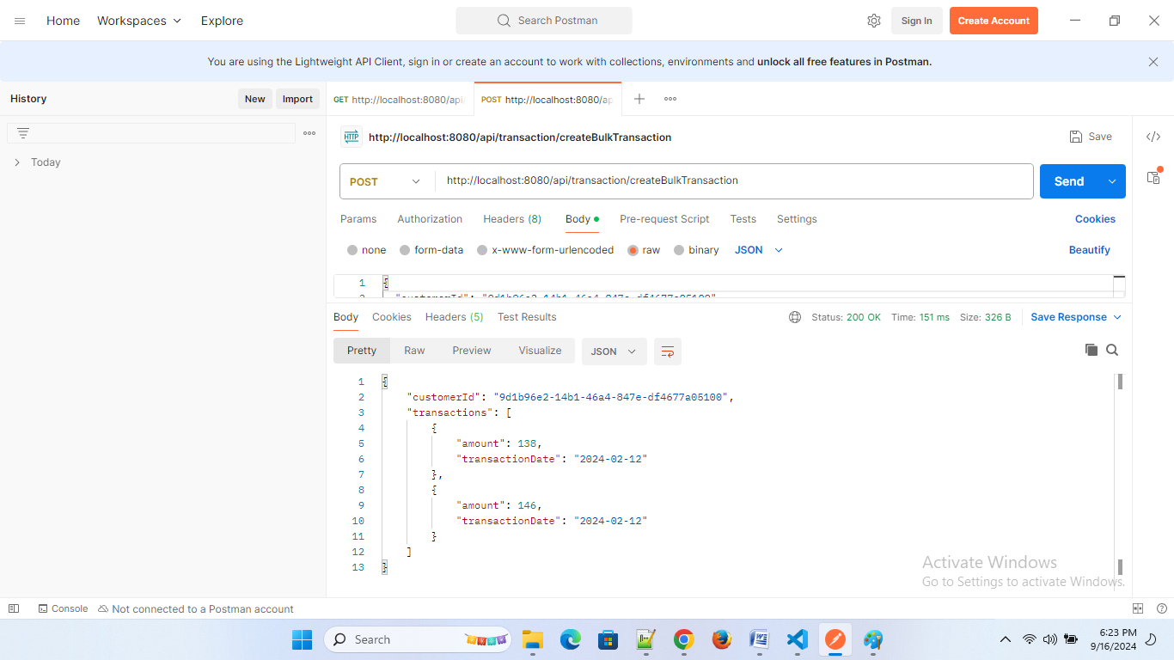

2.Table in memory :H2 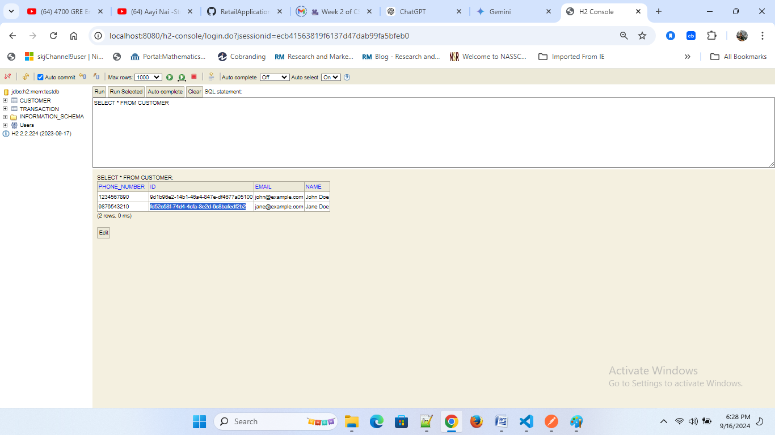

2.Single Transaction for a customer:

curl --location 'http://localhost:8080/api/transaction/createTransaction' \

--header 'Content-Type: application/json' \

--data '{

"customerId": "9d1b96e2-14b1-46a4-847e-df4677a05100",

"amount": 101

}'

3.getReward for a single customer:

curl --location 'http://localhost:8080/api/reward/customer/9d1b96e2-14b1-46a4-847e-df4677a05100'

{

"customer": {

"id": "9d1b96e2-14b1-46a4-847e-df4677a05100",

"name": "John Doe",

"email": "john@example.com",

"phoneNumber": "1234567890"

},

"totalPoints": 52,

"rewards": [

{

"transactionId": "c105205c-709e-47e6-bc37-a1e18acce46d",

"transactionAmount": 101.00,

"points": 52,

"awardedDate": "2024-09-16T18:30:48.52744"

}

]

}

